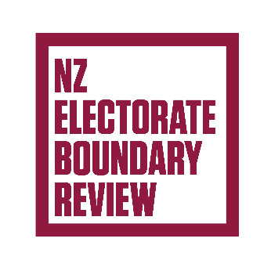

NZ Electorate Boundary Review

Adapted in 2025 by Accessible Formats Service,   
Blind Low Vision NZ, Auckland

**Transcriber's Note**: The logo at the top of the page is NZ Electorate Boundary Review.

# Proposed changes to electorate boundaries

A review is being held to set electorate boundaries for the 2026 General Election.

An electorate is a voting area for parliamentary elections. The review means your electorate or its name could change before the next election.

The Representation Commission is the independent body that reviews and adjusts the boundaries and makes sure each electorate has about the same number of people.

Shifts in population mean that the Commission is proposing changes to most electorate boundaries in the North Island.

## Summary of proposed changes

For the 2026 General Election:

* the number of general electorates in the North Island reduces from 49 to 48
* the number of general electorates in the South Island is fixed at 16
* the number of Māori electorates remains unchanged at 7.

Because the number of general electorates in the North Island is reducing by one, the boundaries of most North Island electorates need to change. The areas of greatest change are the lower North Island, the Auckland region, and the Bay of Plenty region. Population changes and changes to electorate quotas mean that some South Island and Māori electorate boundaries are also proposed to be changed.

The biggest areas of change are the lower North Island where the number of general electorates is reduced by one, the Auckland region and Bay of Plenty.

In the South Island the biggest area of change is around Selwyn in Christchurch

In the Māori electorates, an adjustment is proposed to the boundary between Ikaroa-Rāwhiti and Te Tai Tonga in Lower Hutt. There are no changes proposed for the other five Māori electorates.

The report on the proposed boundaries is available online at <https://vote.nz/boundary-review/boundaries/the-changes/proposed/>. Public libraries also have copies of the report.

Now the proposed boundaries have been released, you can have your say.

Public consultation happens in three stages.

You have until 27 April to make a written objection. You can make an objection online at <https://vote.nz/boundary-review/submit/have-your-say/how/> or by filling in a form, which you can download from the website or pick up from a public library.

From 8 May to 21 May, you can respond to any of the objections that have been raised. That's known as a counter-objection.

There will be public hearings from 9 June to 18 June, and the boundaries will be finalised on 8 August.

Go to <https://vote.nz/boundary-review/about/2025/> for more information on the 2025 Boundary Review.

End of NZ Electorate Boundary Review