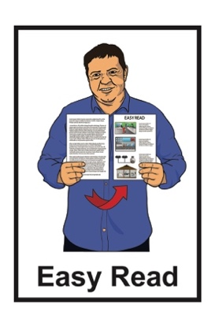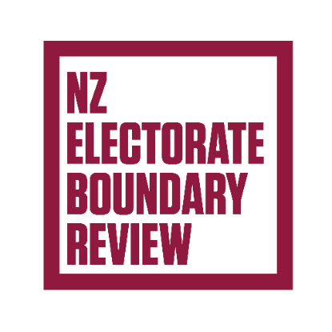

Changes to electorate boundaries –   
Tell us what you think

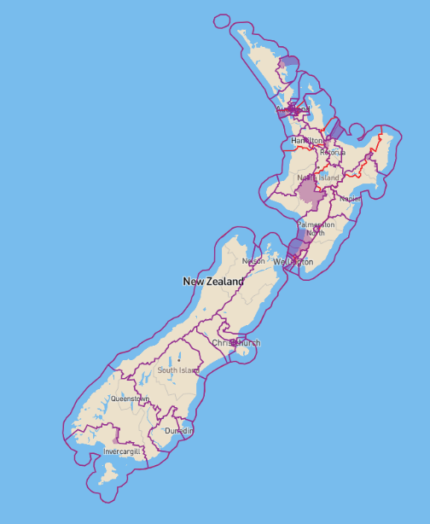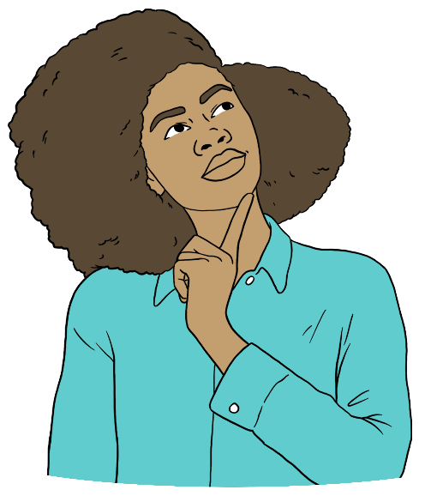

Published: May 2025

# Before you start

Some of the ideas in this Easy Read document might be hard to understand.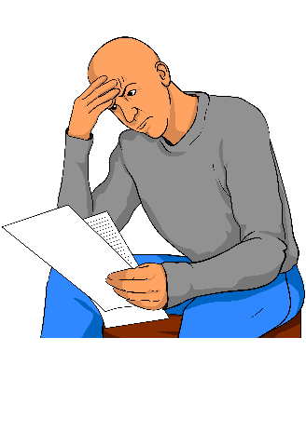

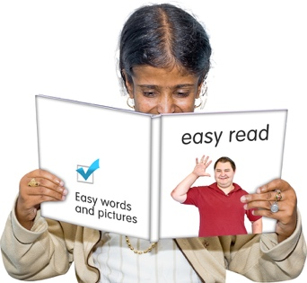You might want to:

read it a few pages at a time

set aside some quiet time to look at it

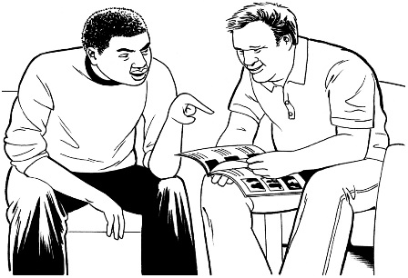have someone read it with you to support you to understand it.

# About this document

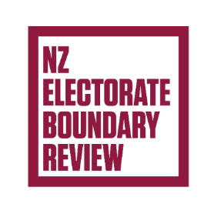

This Easy Read document is from the **Representation Commission.**

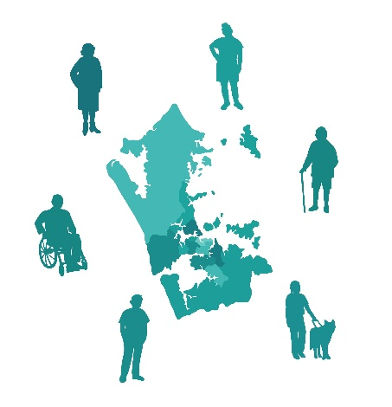The **Representation Commission** is the **independent** group that:

checks **electorate boundaries**

changes electorate boundaries.

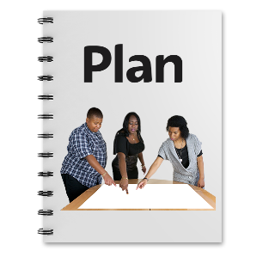

**Independent** means that they make choices:

by themselves

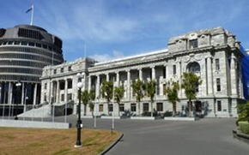

without the government telling them what to do.

In this document when it says   
**we / us** it means the Representation Commission.

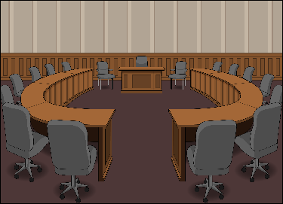**Elections** are when you **vote** for people to be part of:

local councils

the government.

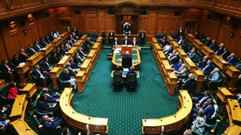**Voting** means saying who you think should be part of the New Zealand Government.

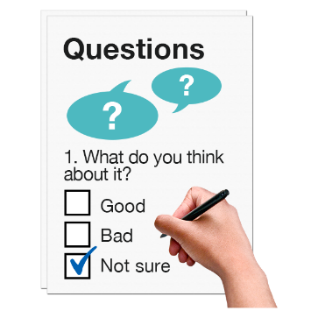

This Easy Read is about how to have your say about some changes to electorate boundaries in Aotearoa New Zealand.

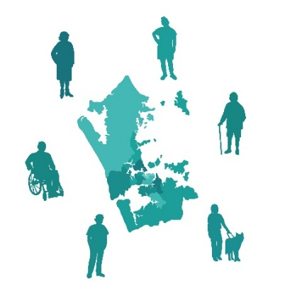An **electorate** is an area used for votingin the **New Zealand General Election.**

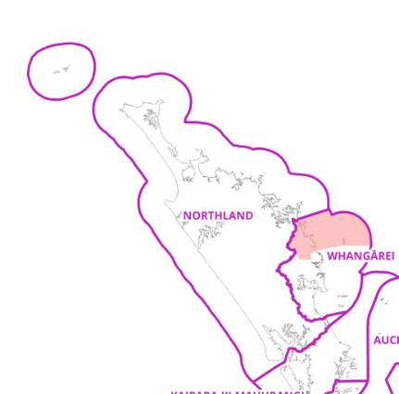**Electorate** **boundaries** are the lines around electorates that show what part of the country is part of each electorate.

The **New Zealand General Election** is when you vote for who you would want to be part of the New Zealand Government.

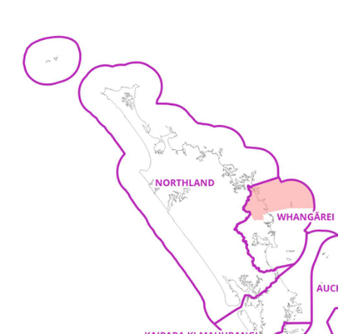

This **review** means some things could change about your electorate before the next General Election like:

its boundary

its name.

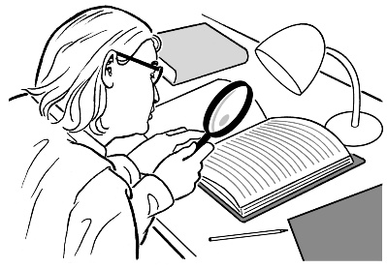A **review** looks at:

how things are now

what might need to change.

We want to know what you think about the changes we want to make.

# Why should these changes be made?



The Representation Commission makes sure that each electorate has about the same number of people.

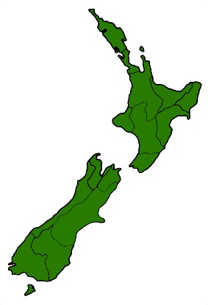They do this after every census.

The Representation Commission wants to make these changes because the number of people in New Zealand has changed a lot.

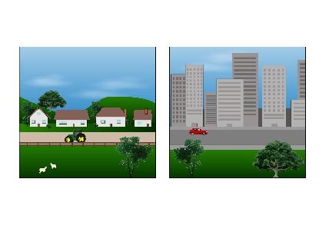

This means that the number of people living in different electorates has also changed a lot.

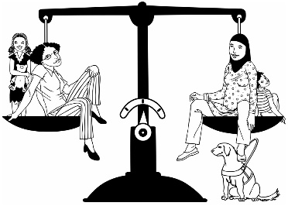

They want to change the electorate boundaries to make the number of people in each electorate more even.

# What changes might be made?

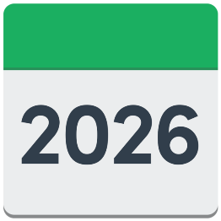

The changes we want to make for the 2026 General Election are:

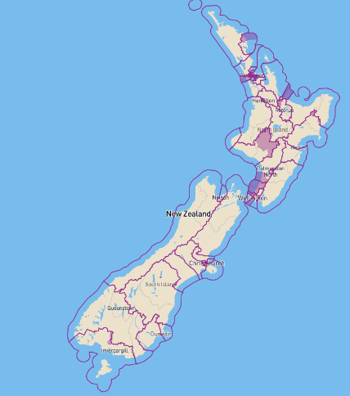the number of **general electorates** in the North Island changes from   
49 to 48

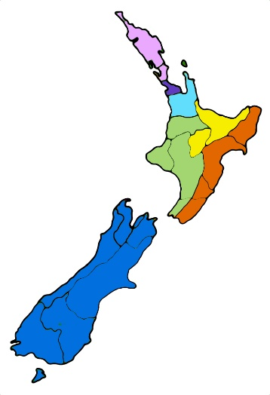the number of general electorates in the South Island stays at 16

the number of **Māori electorates** stays at 7.



A **general electorate** is an   
electorate where everyone can vote for the people they want to speak for them in parliament.

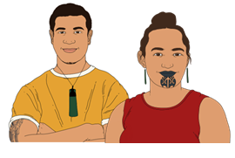A **Māori electorate** is an electorate that Māori can choose to vote in instead of the general electorate.



The boundaries of the North Island electorates need to change because the number of general electorates in the North Island is going down by 1.

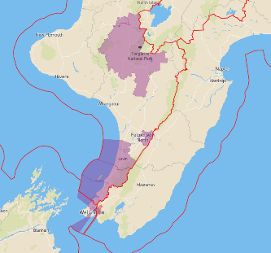

The areas that would change the most are:

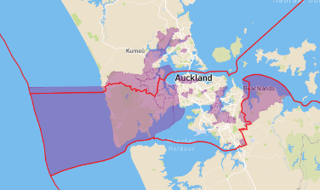the lower North Island

Auckland

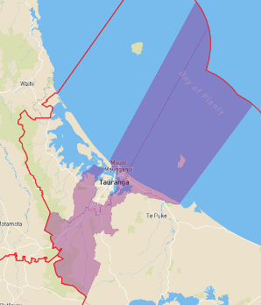Bay of Plenty.

This is because these are the areas that have had the most changes in the number of people living there.

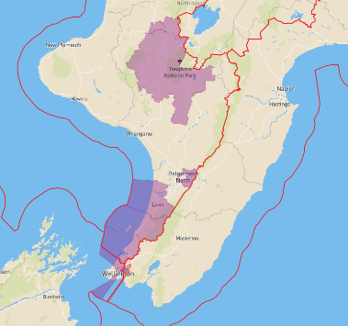The lower North Island is where we will want to take away an electorate to make the total North Island electorates 48.

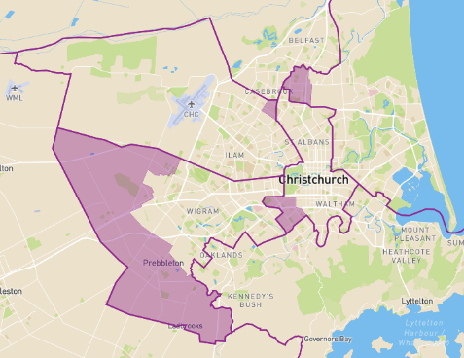

The biggest area that may change in the South Island is around Selwyn in Christchurch.

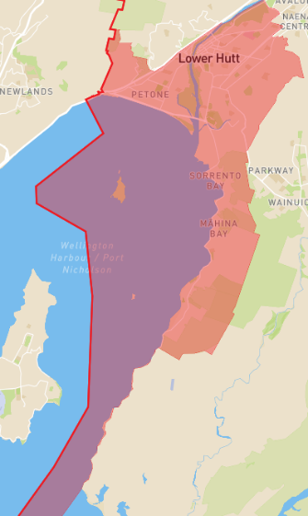The change to the Māori electorates is to the boundary between Ikaroa-Rāwhiti and Te Tai Tonga in Lower Hutt.

There are no changes we are suggesting for the other Māori electorates.

# How to tell us what you think

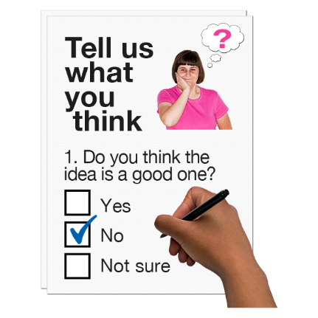

You can tell us what you think about the boundary changes we want to make.

This is called **public consultation.**

**Public consultation** is how we find out what New Zealanders think of   
the changes.

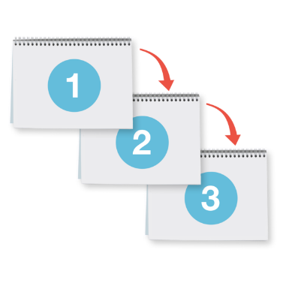

Public consultation happens in 3 stages.

## Stage 1 – Making an objection

An **objection** is when you say why you do not:

like something

think that change should happen.



You can read objections people have made on the Vote NZ website at:

****[**https://bit.ly/votenz-br-objections**](https://bit.ly/votenz-br-objections)

This website is **not** in Easy Read.

Objections closed **27 April 2025**.

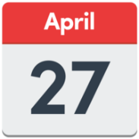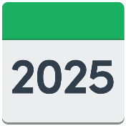

You cannot make objections anymore.

## Stage 2 – Counter-objections

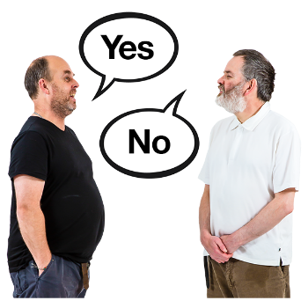A **counter-objection** is when you say why you do not agree with objections from other people.

You can counter-object to any of the objections that have been given.

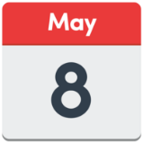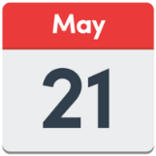

You can make a counter-objection from **8 May 2025** until **21 May 2025**.



You can make a counter-objection on the Vote NZ website at:

****[**https://bit.ly/votenz-br25-counterobjection**](https://bit.ly/votenz-br25-counterobjection)

This website is **not** in Easy Read.

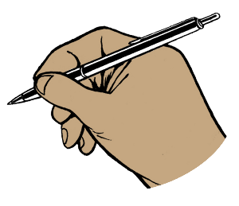You can also make a   
counter-objection by filling out a

counter-objection form.



You can download the   
counter-objection form from the Vote NZ website at:

[**https://bit.ly/Votenz-br25-counterobjectionpdf**](https://bit.ly/Votenz-br25-counterobjectionpdf)



This form is **not** in Easy Read.

## Stage 3 – Public Hearings

A **public hearing** is when we meet with people to talk about the changes we are suggesting.

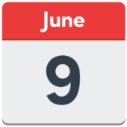

We will have public hearings from   
**9 June 2025** until **18 June 2025**.



We will choose what is going to change after listening to everyone.

This choice will be made on   
**8 August 2025**.

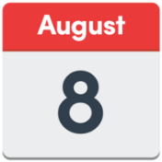

# Where to find more information

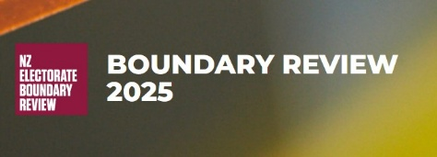You can find more information about the boundary review at this **website**:

[**https://bit.ly/votenz-br25-about**](https://bit.ly/votenz-br25-about)

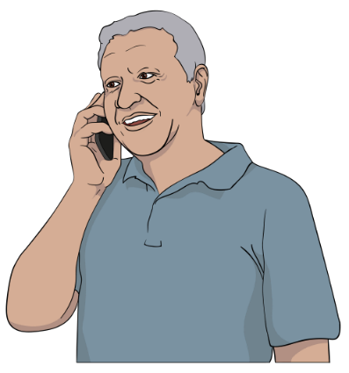

You can also contact us by:

**Phone: 0800 36 76 56**

**Email:** [**enquiries@elections.govt.nz**](mailto:enquiries@elections.govt.nz)



Send us a question online by filling in our enquiry form at:

**https://vote.nz/contact-us**

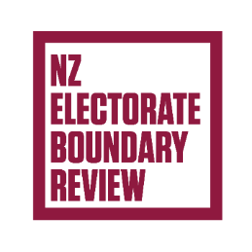This information has been written by the Representation Commission.

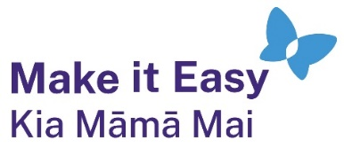It has been translated into Easy Read by the Make it Easy Kia Māmā Mai service of People First New Zealand Ngā Tāngata Tuatahi.



The ideas in this document are not the ideas of People First New Zealand Ngā Tāngata Tuatahi.



All images used in this Easy Read document are subject to copyright rules and cannot be used without permission.

Make it Easy uses images from:

* Photosymbols
* Change Images
* Huriana Kopeke-Te Aho

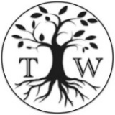

* SGC Image Works
* T Wood
* 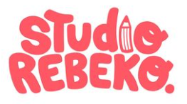Studio Rebeko
* Inga Kramer.