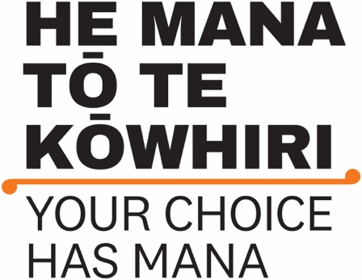
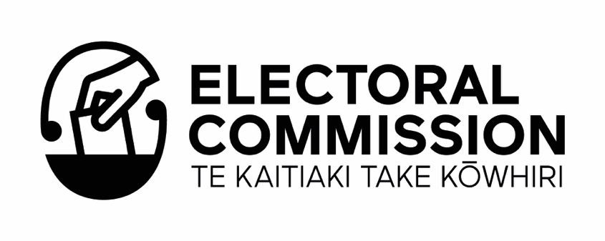

Information about the

Māori Electoral Option –
Te Kōwhiringa Pōti Māori
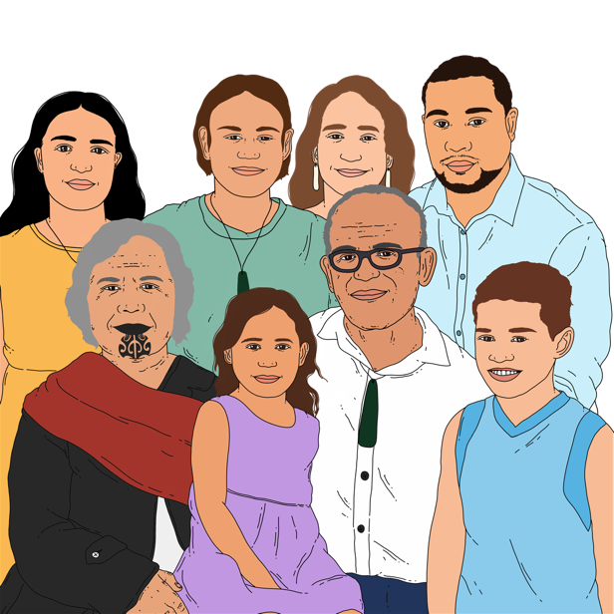
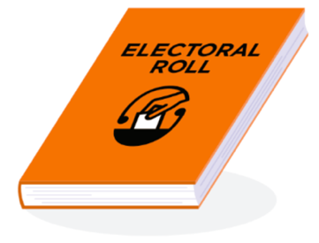

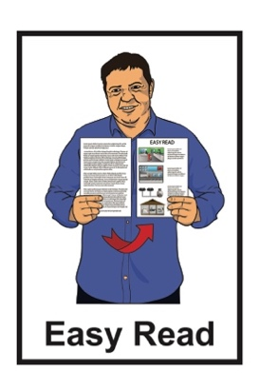

Published: May 2023

Before you read this document
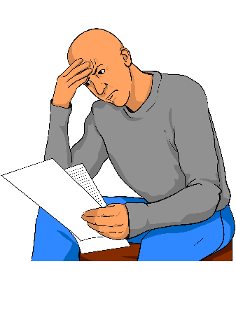

This Easy Read document talks about things to do with elections in New Zealand.

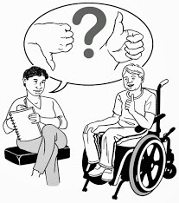
An election is the time when you can vote for the people you want to make important decisions about:
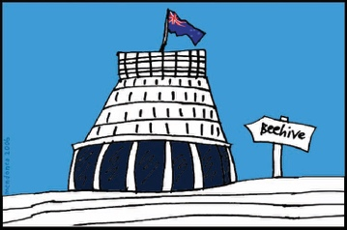
- things that affect how you live
- the country you live in.

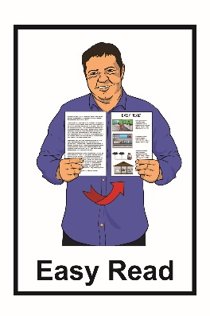
While this document is written in Easy Read it uses some hard words which you might not know.

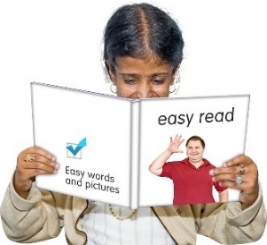
Some things you can do to make it easier are:

- read a few pages at a time
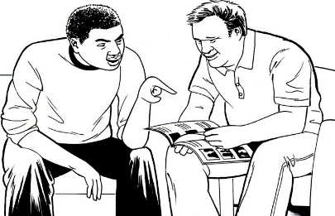
- have someone support you to understand it.

What you will find in here

Page number
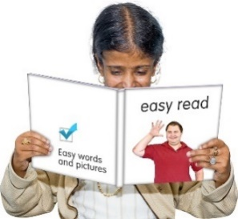

What is this document about? 5

What is the Electoral
Commission? 7

What are the electoral rolls? 9

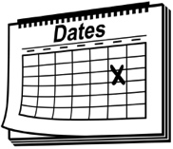
When you can change the
roll you are on 14
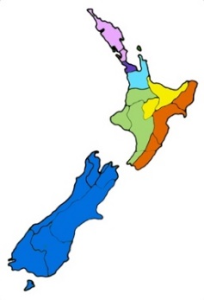

What is an electorate? 17

Page number
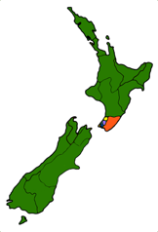

What is a local council ward
or constituency? 21

Voting in general and
by-elections 25
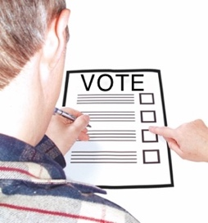

Voting in local elections 27

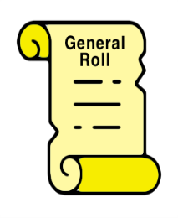
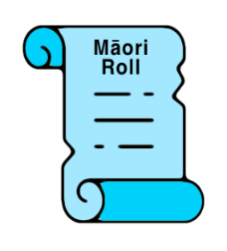
How to change which roll you
are on 28

Where to find more information 32

What is this document about?

This Easy Read document is from the Electoral Commission about the Māori Electoral Option –
Te Kōwhiringa Pōti Māori.

We will talk more about the Electoral Commission on pages 7 to 8 of this document.
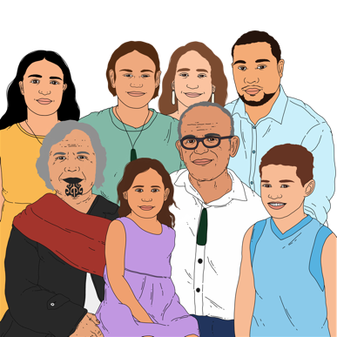

The Māori Electoral Option is a choice for Māori about which electoral roll they want to be on.

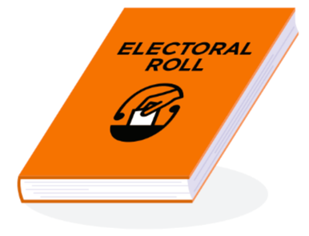
The electoral roll is a list of all the people in New Zealand who have enrolled to vote.

Being enrolled to vote means:
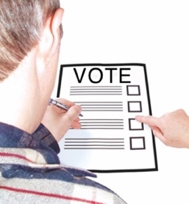
- your name is on the electoral roll
- you can vote in an election.

When you vote you get to have your say about who you think should win an election.

An election is the time when you can vote for the people you want to make important decisions about:
- things that affect how you live
- the country you live in.

What is the Electoral Commission?

The Electoral Commission:
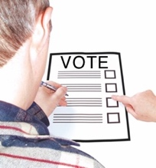
- looks after the running of parliamentary elections in New Zealand
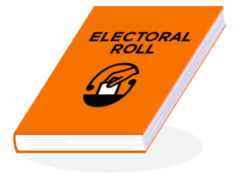
- works to keep the electoral rolls up to date.

Parliamentary elections are when people get to vote for who will be a member of Parliament.

Someone who is a member of Parliament is also called an MP.

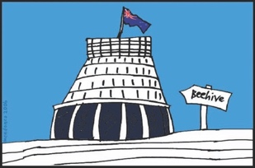
An MP is someone who:
- works in Parliament
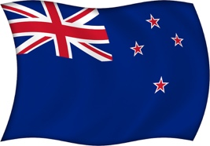
- works to represent the people of New Zealand
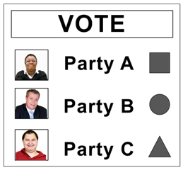
- usually represents a political party.

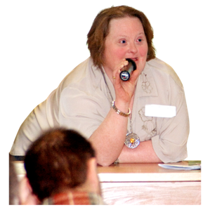
Represent means to stand / speak for someone.

What are the electoral rolls?

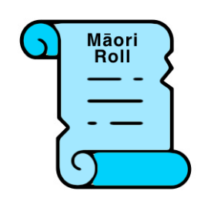
The electoral roll is split into 2 lists:
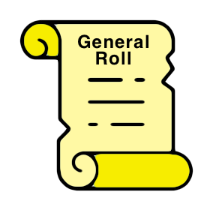
- the Māori roll that is open to voters who are Māori
- the general roll that is open to all voters.

No one can be on both rolls at the same time.

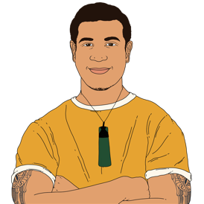
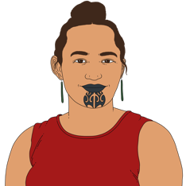
You can choose which electoral roll you want to be on if:
- you are Māori
and
- you are enrolling to vote for the first time.
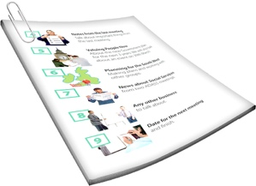
There is more information later in this document about changes you can make once you are already enrolled to vote like:
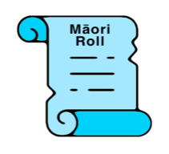
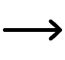
how you can change which electoral roll you are on
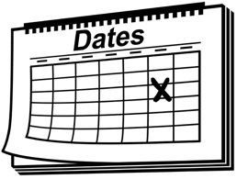
when you can change which electoral roll you are on.

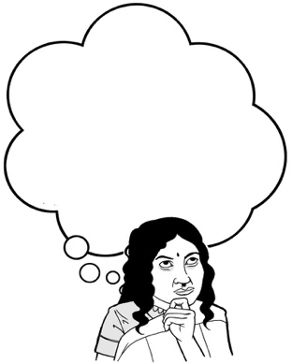
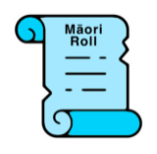
The information in this document can support people to make their choice about which electoral roll they want to be on.

It is a good idea to share the information in this document with people you know who are not yet enrolled to vote.

To get enrolled to vote in New Zealand you must:
18

- be at least 18 years old

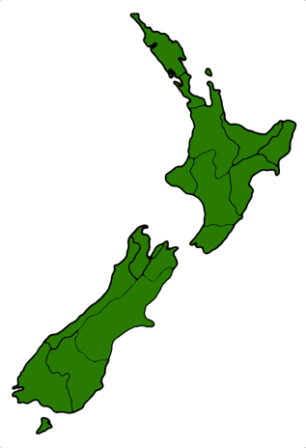
and

- have lived in New Zealand for more than 1 year at some time in your life

and
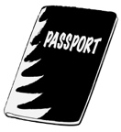
- be:

- a New Zealand citizen
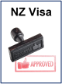
or

- a New Zealand permanent resident.

A New Zealand citizen is someone who can get a New Zealand passport.
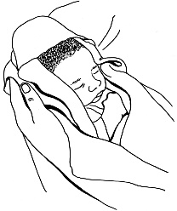
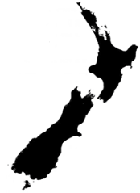

Most New Zealand citizens were born in New Zealand.

A New Zealand permanent resident is someone who:

- is not a New Zealand Citizen.
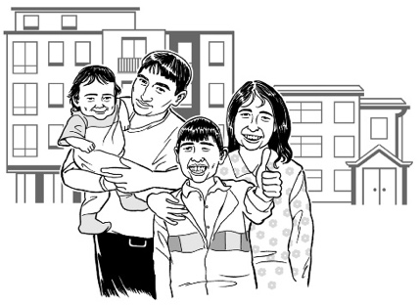
- has been told by the government they can live in New Zealand all the time.
The people you vote for in an election are called candidates.

The candidate with the most number of votes becomes an MP.
It is important to know that the electoral roll you choose to be on affects which candidates you can vote for in elections.

When you can change the roll you are on

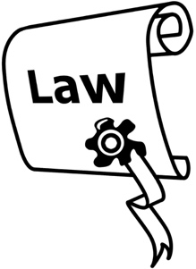
The law about electoral rolls changed on 31 March 2023.

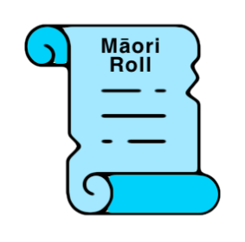
This change to the law means you can usually change which electoral roll you are on at any time.
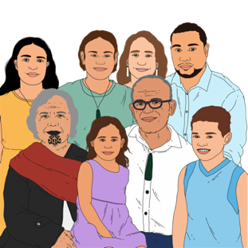

You can only change which electoral roll you are on if you are Māori.

The times you cannot change which electoral roll you are on are:
- in the 3 months before a general election happens
- in the 3 months before a local election happens.
The other time you cannot change which electoral roll you are on is:
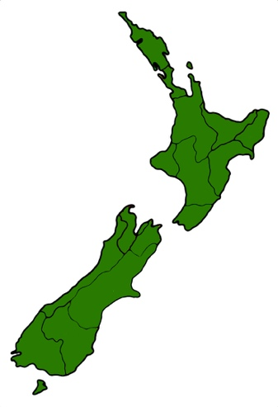
before a by-election
if
it moves you into the area / electorate where the by-election is being held.

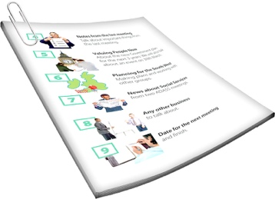
We will talk about electorates on page 17 of this document.

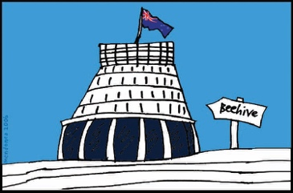
A general election is when people vote for who they want in Parliament.

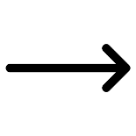
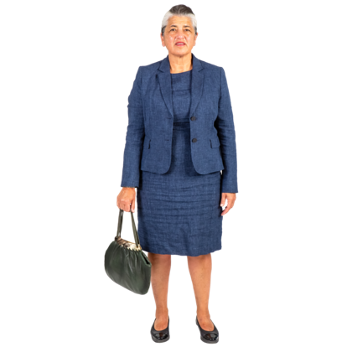
A local election is when people vote for who they want to be part of the councils in the place they live.

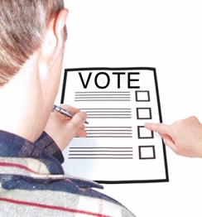
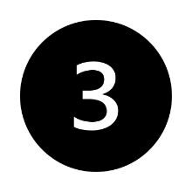
These 2 kinds of elections happen every 3 years.

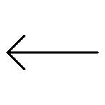
A by-election happens when a member of Parliament leaves their job before a general election.
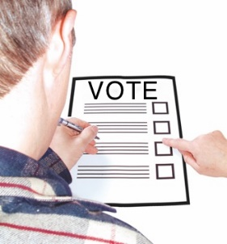

When this happens people in their area vote on who will replace them.

What is an electorate?

New Zealand is divided into voting areas called electorates.

Divided means it is split into parts.

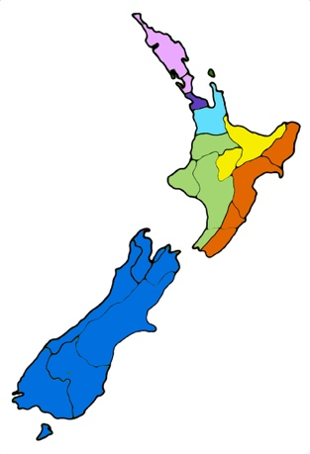
There are 2 kinds of electorates:
- Māori electorates

- general electorates.
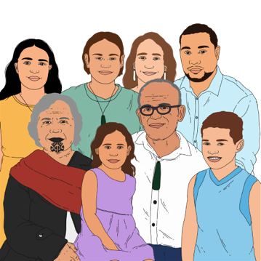

A Māori electorate is a voting area where only people who are on the Māori electoral roll can vote.

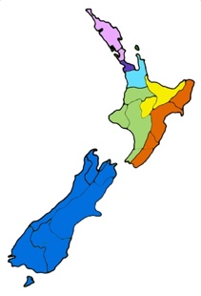
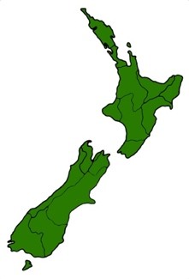
Every place in New Zealand is part of both:
a Māori electorate
a general electorate,

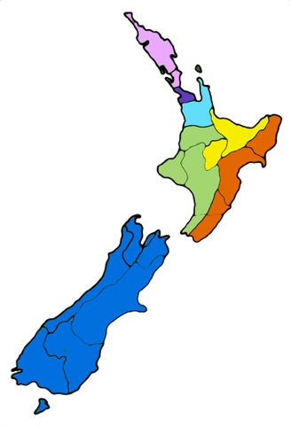
In New Zealand there are currently:
- 7 Māori electorates
- 65 general electorates.
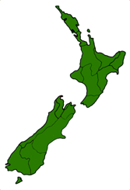
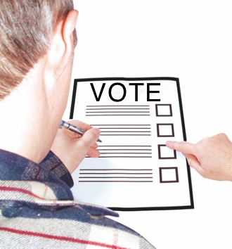
When you enrol to vote you are also enrolled in the electorate where you live.

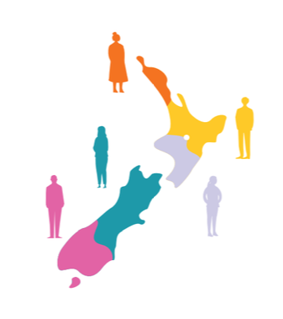
Electorates:
- are not always the same size

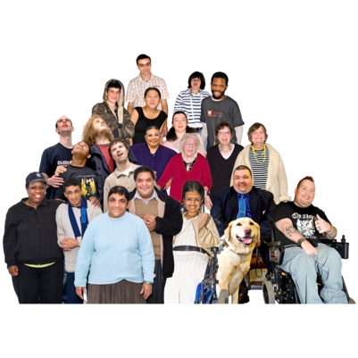
but
- they usually have around the same number of people in them.

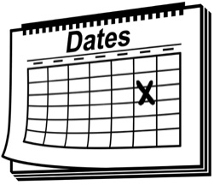
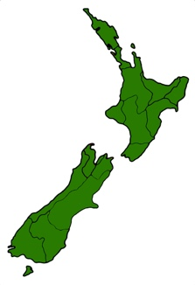
The boundaries of electorates can change / move over time.

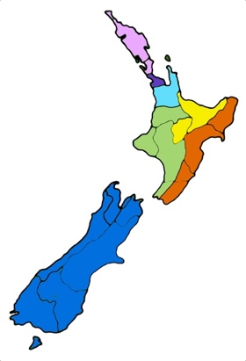
Boundaries means the edges of the area of land that makes up an electorate.

A thing that can affect where the boundaries of electorates are is:
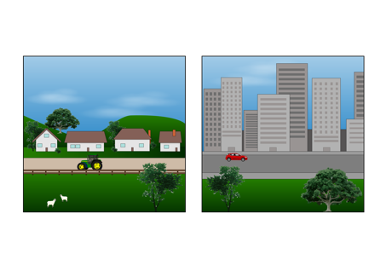
how many people choose to be on the Māori roll
which places those people live in.

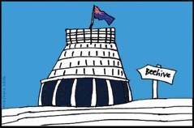
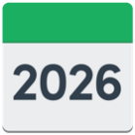
The next time electorate boundaries will be looked at will be before the General Election in 2026.

What is a local council ward or constituency?

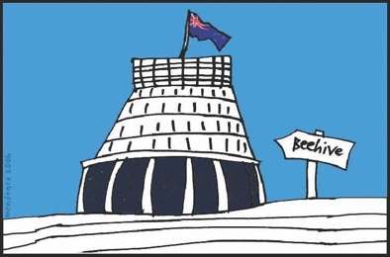
Local government is separate from central Government.

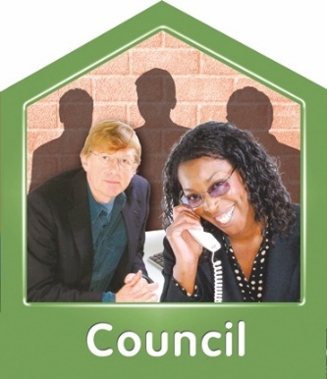
Local government in New Zealand is currently made up of:
11 regional councils
11 city councils
50 district councils
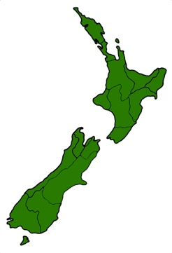
6 other council areas.

Regional councils look after large areas of land called regions.

There are 16 regions in New Zealand.

Regions have voting areas called constituencies.

City councils look after the cities in New Zealand.

District councils look after areas that are not part of cities.

City councils / district councils have voting areas called wards.

Most places in New Zealand are part of both:
a region
and
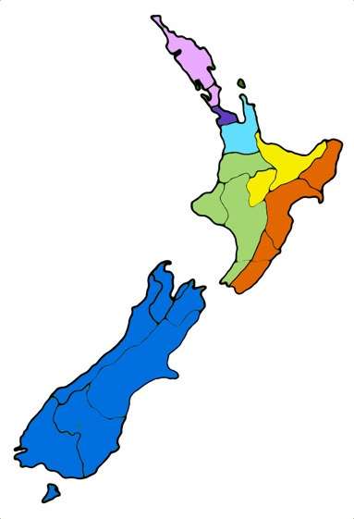
a city or a district.

Some councils have both:
- Māori wards / constituencies
- general wards / constituencies.

In a local election you vote for people called councillors who will represent the people in each ward / constituency.

These voting areas:
- are not always the same size

but
- they usually have around the same number of people in them.

Voting in general and by-elections

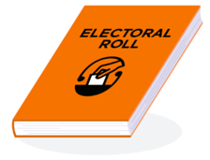
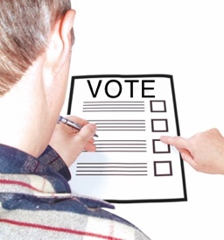
The electoral roll you choose to be on affects who you can vote for in elections.

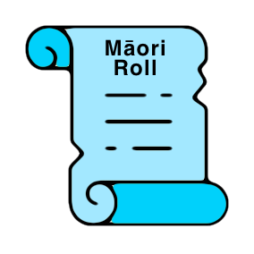
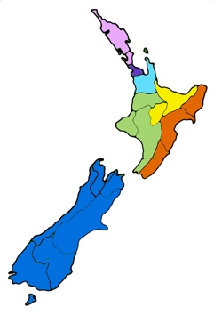
If you choose to be on the Māori electoral roll you will vote for a candidate in the Māori electorate you live in.

If you choose to be on the general electoral roll you will vote for a candidate in the general electorate you live in.

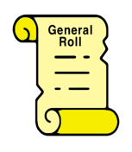
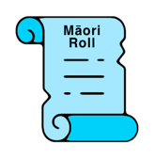
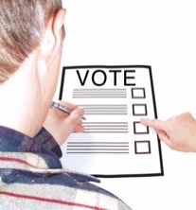
In a general election everyone can still vote for the same list of political parties.

The electoral roll you choose to be on may change how many electorates there are for general elections.

The number of Māori on the Māori electoral roll can also change how many Māori electorates there are by:
- making more
- making fewer
- keeping the same amount.

Voting in local elections

In local elections you will vote for candidates in a Māori ward / constituency if:

- you choose to be on the Māori electoral roll

and
- your local council has a Māori ward / constituency.

If you choose to be on the general electoral roll you will vote for candidates in the general ward / constituency.

How to change which roll you are on

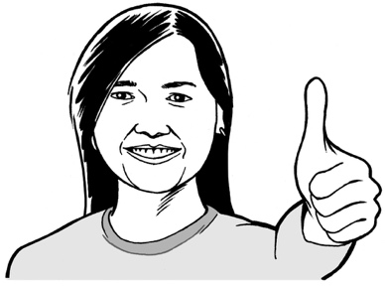
If you are happy with the electoral roll you are on you do not need to do anything.

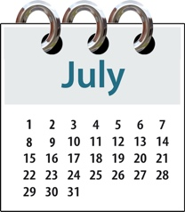
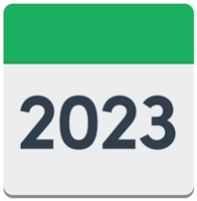
If you want to change which electoral roll you are on you can do this before 13 July 2023.

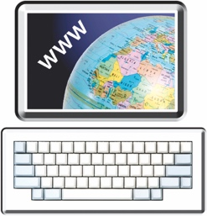
You can change which electoral roll you are on by:
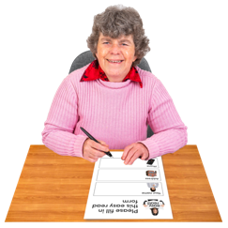
- going to the website at:
vote.nz
- filling in a paper enrolment form and sending it back to us.

You can also enrol to vote for the first time.

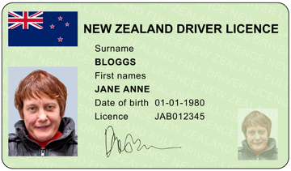
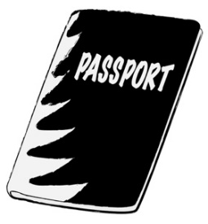
If you choose to change your electoral roll online you must have a form of ID like:
- a New Zealand driver licence
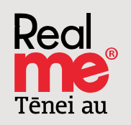
- a New Zealand passport
- a RealMe verified identity.

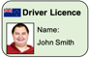
A form of ID is an official document that you can use to prove who you are.
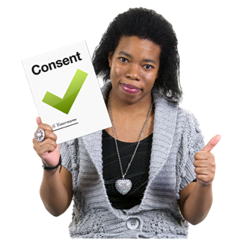

Verified means something that has been checked to make sure it is true.

We can also send you a paper enrolment form by post.

You can call us to ask us to send you a paper enrolment form on:

0800 36 76 56
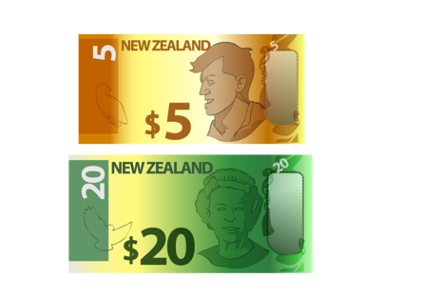
It will not cost you any money to call this number.

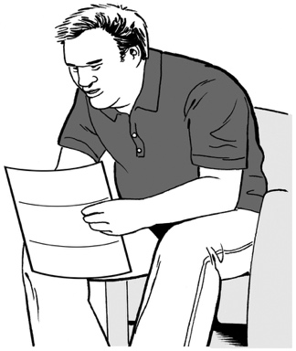
Some Māori who are already enrolled to vote have been sent an information pack by post about the Māori Electoral Option.

You can change which electoral roll you are on by sending us the letter that is in the information pack.

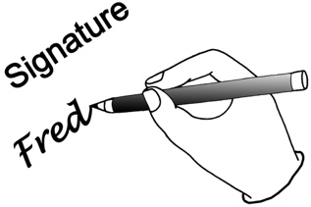
Before you send the letter to us make sure you:
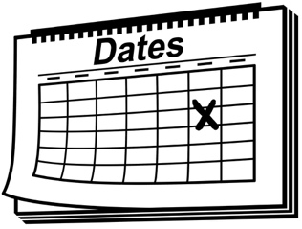
- sign it
- put the date on it.

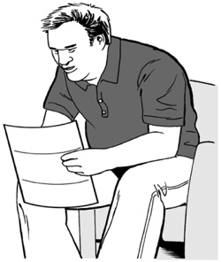
It does not matter if you did not get the information pack sent to you.

Some people choose to be on the unpublished electoral roll.

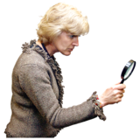
The unpublished electoral roll means that information about you like your address will not be published where other people might see it.

If you are already on the unpublished electoral roll you will need to fill in a paper enrolment form to change which electoral roll you are on.

Where to find more information

Our website has more information about:
- the Māori Electoral Option
- enrolling to vote.

The website address is:
vote.nz

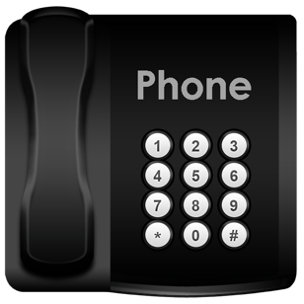
You can also call us with any questions you have on:

0800 36 76 56
It will not cost you any money to call this number.
This information has been written by the Electoral Commission.

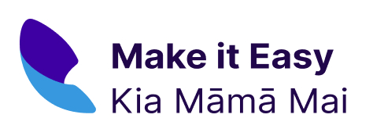
It has been translated into Easy Read by the Make it Easy Kia Māmā Mai service of People First New Zealand Ngā Tāngata Tuatahi.

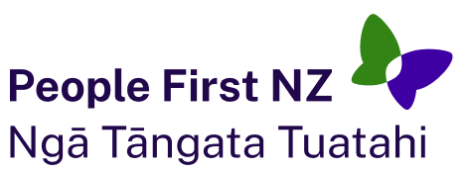
The ideas in this document are not the ideas of People First New Zealand Ngā Tāngata Tuatahi.

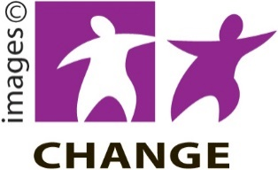
Make it Easy uses images from:

- Changepeople.org

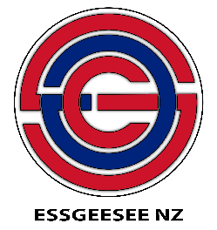
- Photosymbols.com

- SGC Image Works

- Huriana Kopeke-Te Aho.
All images used in this Easy Read document are subject to copyright rules and cannot be used without permission

