**NO CHANGE To CURRENT EPSOM ELECTORATE PLEASE!!!**

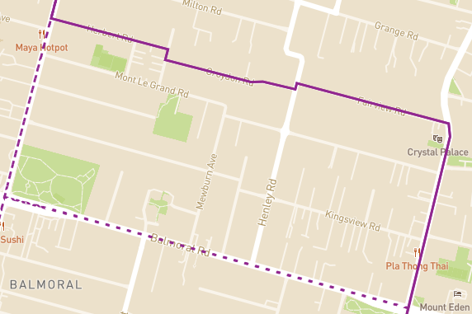

I don't support the change of splitting Kingsview Road out of Mount Eden to Mount Albert. Epsom is an electorate that places a strong emphasis on education. The change would undermine the strong community of interest. People in Epsom have long voted for local representatives who share our values of aspiration and education.

Keep the current boundaries of the Epsom electorate. The proposed change does not make sense!